2026.1.13周二晚间任务（读熟并弄懂句子意思及单词拼写，上课检查）
假设你是李华，你的美术老师带你去公园上了一节美术课，请你写一封信给Chris, 内容包括：
1. 你完成的作品；2. 你的感想。

I’m writing to share with you an unforgettable art class I had in the park last Friday. The sunset cast a golden glow on the trees, flowers, and the lovely lotus pond where ducks were swimming gracefully. Nearby, some elderly people were engaged in square dancing, their faces radiating joy and energy.
This outdoor session was a delightful break from conventional classes, allowing me to dive into hands-on practice. How therapeutic it was to be surrounded by nature, breathing in the fresh air and feeling the mild breeze! It offered me a perfect escape from my demanding academic routine.
I truly cherish this experience and would love to hear about any similar memories you might have. Looking forward to your stories!

2026.1.14周三晚间及周四早读任务（清楚单词拼写及意思，可能会有单词意思拓展）
1. humor-humorous, mystery-mysterious, harmony-harmonious
2. shining jewels发光的珠宝
3. see through a lame excuse看穿蹩脚的借口
4. eliminate widespread suspicion消除普遍的怀疑
5. marry-marriage, merry-merriment
6. deposit some of his salary as nest eggs for retirement存一点工资用作储蓄金以备退休
7. origin-original-originate, original原件，originals原件（复数）
8. loyal忠诚的,loyalty，royal皇室的
9. leak confidential information泄露机密信息
10. be senior to sb by +年龄：比某人大几岁，be junior to sb. by+年龄：比某人小几岁
11. acquire-acquisition, enquire-enquiry, require-requirement
12. romance, romantic, romanticize
13. contact, contrast, contract
14. recover / restore the lost prize 找到丢失的奖牌
15. transferred, preferred, occurred, referred
16. prior, priority, prioritize
17. be in a low profile低调
18. muscular arms, a miraculous recovery
19. It’s sensible to pursue a hybrid strategy to address the issue.为解决该问题，采取混合策略是合理的。
20. favorite最喜欢的，favorite可用作名词，喜欢的物品，favorites
21. strike a balance between A and B求得平衡, strike a bargain达成协议
22. a modest mindset谦虚的心态，a conservative mindset保守的心态
23. be symbolic of象征着，artistic, athletic, academic
24. a welcome change of scenery令人愉快的环境变化
25. take in the breathtaking views欣赏令人惊叹的景色
26. be in one’s element如鱼得水
27. beat the heat避暑
28. supplement增补，complementary补充的
29. exceed one’s expectations超出期望
30. prosperous-prosperity, rejuvenate复兴，print in portrait / landscape style
2026.01.15周四晚间任务（弄懂这种应用文的写法，注意语言的灵活运用）
假定你是李华，春节期间你将与来自英国的交换生Tom从济南出发前往上海旅行。你为他预定了往返高铁票。请给他写一封邮件，内容包括：
（1）车次信息；（2）注意事项。
08:00 G6 12:00
济南西 历时4小时 上海虹桥
发车时间： 2026.02.19 星期四
TOM SMITH 学生票 二等座08车11B号
外国护照 ￥410

14:00 G15 18:00
上海虹桥 历时4小时 济南西
发车时间： 2026.02.23 星期一
TOM SMITH 学生票 二等座12车01A号
外国护照 ￥410

I’m excited about our upcoming trip to Shanghai! I’ve finalized our high-speed train bookings.
We’ll depart from Jinan West Railway Station at 08:00 on February 19th on train G6, with an estimated travel time of 4 hours, and arrive at Shanghai Hongqiao Railway Station at noon. Our return journey is scheduled for February 23rd on train G15, departing at 14:00 and arriving in Jinan at 18:00. We’ve secured second-class seats for both legs of the journey.
Please remember to bring your passport and arrive at the station about 30 minutes in advance for a smooth check-in. I am truly looking forward to sharing the train ride and exploring Shanghai with you. Should you have questions, just feel free to call me.

2026.1.18周日晚间任务（仔细研究看图作文的写法，读至少5遍）
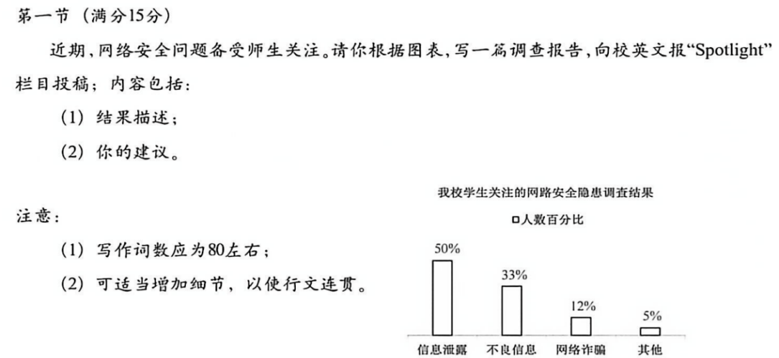
A recent survey conducted in our school has shed light on students' major concerns regarding online safety. According to the results, half of the respondents view information leakage as their primary worry. Meanwhile, exposure to misleading content and online fraud accounts for 33% and 12% respectively, while the remaining 5% cite other potential cyber risks.
To address these issues, practical measures should be taken. Students are advised to enhance privacy settings and refrain from oversharing personal information. It is also essential to recognize and avoid suspicious links and untrustworthy websites. Furthermore, cultivating critical thinking can help assess the reliability of online content. Schools and parents are encouraged to offer regular guidance to foster responsible digital behavior.
I am firmly convinced that with our concerted efforts, students' awareness of internet security will be greatly heightened, paving the way for a safer and more trustworthy online environment for all.

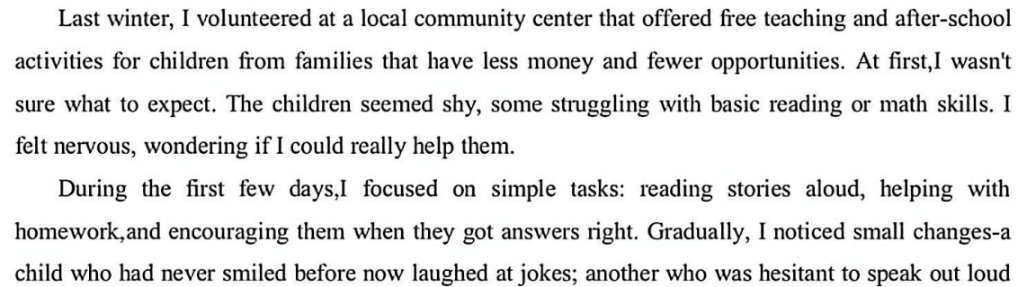
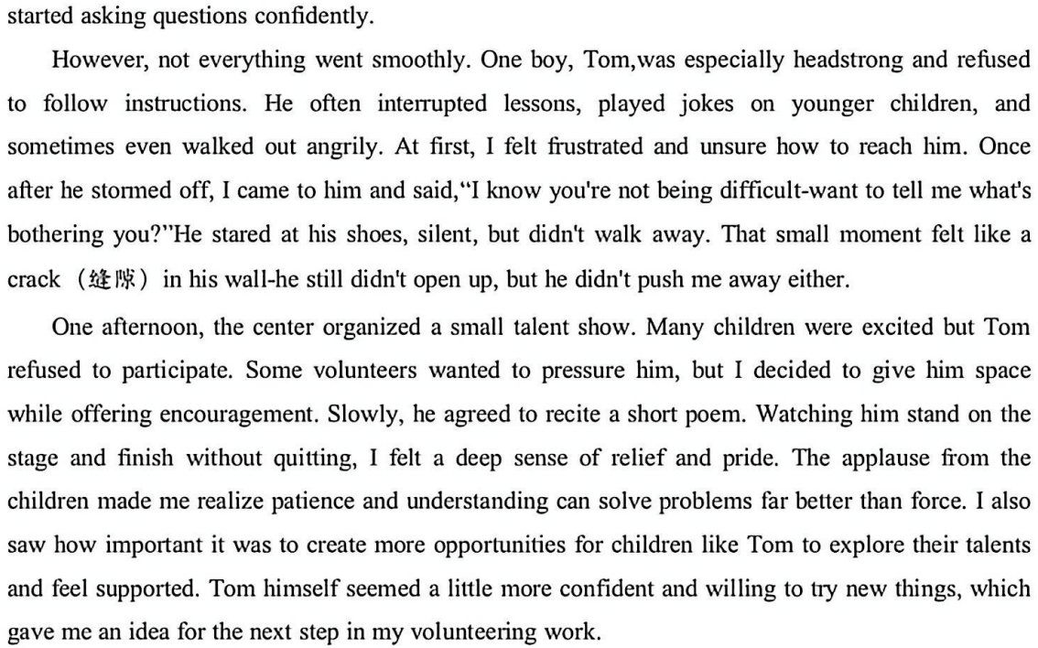

I knew I had to do more for Tom and the other children. Inspired by the talent show, I designed creative activities, such as poetry, drawing, simple experiments, to spark their curiosity. Slowly, these worked wonders, opening their hearts and minds. Tom was particularly drawn to building model airplanes. One quiet afternoon, he approached and placed a carefully folded paper plane in my hand. On its wing, traced in pencil, were the words “Thank You.” In that moment, I felt a profound quiet joy: my efforts had not just reached him, but were tenderly returned.
Tom changed clearly over the weeks. That paper plane was a turning point. Shedding his former defiance, Tom began to shine with a calm enthusiasm for learning. Capitalizing on this change, I launched a weekly “Exploration Hour.” He naturally became a helper, guiding younger children. Watching him patiently teach a shy girl to fold her first airplane, I saw not just a boy transformed, but a leader emerging. The teaching experience told me that the greatest change often begins with the smallest act of trust. And I understood that every young heart, given patience and space, can unfold its wings and soar toward light.

（2026.1.19周一晚间及周二早读任务（济宁，阅读该范文至少5遍以上）
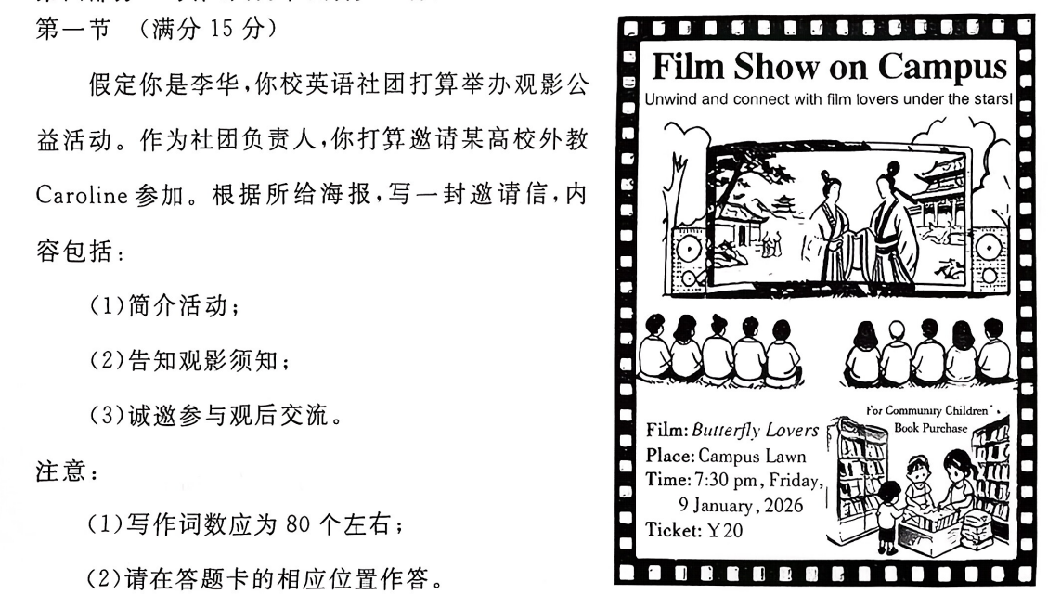
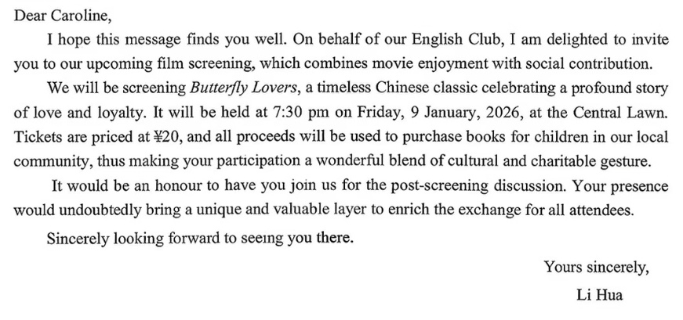
(2026.01.20周二晚间任务：2026.01浙江应用文，阅读至少5遍）
假如你是李华，你发现校图书馆的藏书存在被勾画涂改的现象。请你向校园电台投稿，内容包括：
1. 具体陈述现象；
2. 呼吁爱护书籍。
Recently, exploring the shelves of our school library, I have been deeply disheartened to see many beloved books bearing the marks of thoughtless handling. Words are scribbled in margins, pages are torn out, and covers are creased and worn. Such rude actions not only damage the books physically but also disrespect our shared intellectual space, robbing future readers of the joy of reading.
Books serve as gateways to knowledge and imagination, opening doors to endless possibilities. Our library’s collection is a shared treasure, and it is our collective responsibility to preserve it. Le’s handle each book with the utmost care, safeguarding it from damage and ensuring its prompt return.
By doing so, we guarantee that these invaluable resources can continue to enrich our academic lives for years to come. A book in good hands benefits us all. Let’s act now!

(2026.01.21周三晚间及周四早读任务：2025.03济宁一模，阅读至少5遍）

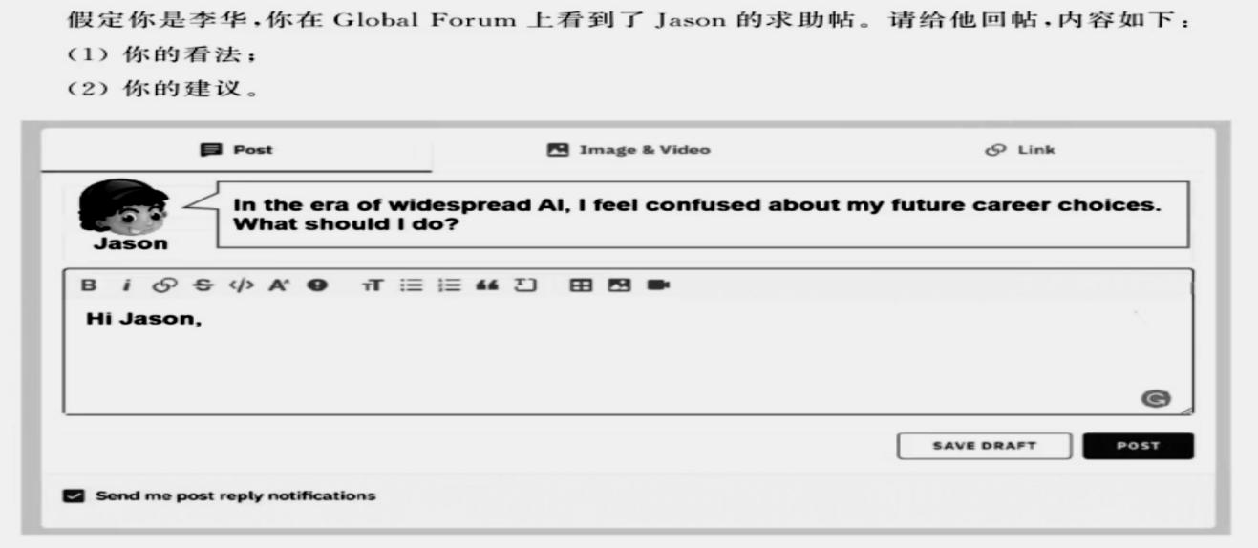
I completely understand your concern. The rise of AI is reshaping the professional landscape, yet it’s creating new opportunities even as it transforms traditional roles. The key is to align your path with a future where human and machine intelligence collaborate, not compete.
To make a concrete choice, I suggest focusing on two types of roles. First, consider careers centered on uniquely human skills, such as counselling, creative arts, or strategic management. Second, explore roles that build, guide, or apply AI, like AI ethics, data analysis, or human-computer interaction design. These fields are not only resilient but also in growing demand.
Embrace a mindset of lifelong learning, especially in digital literacy. By combining your innate strengths with technological awareness, you’ll find a career that is both fulfilling and future-proof.

(2026.01.22周四晚间任务）
1. 请确保带着护照和一些必需品。（Please ensure that you bring your passport and some necessities.）
2. cultivate fertile imagination
3. We should take pictures at designated areas in order not to disrupt teaching and studying.
4. stand up for ...力挺
5. stay put待着别动
6. Her slumped shoulders straightened and sparks in her eyes blazed anew.
7. True brilliance consists not in the success achieved, but in the exertion involved.
8. successive wins连续的成功
9. No paintings can do justice to her beauty.没有画可以画出他的美。
10. Please accept this humble souvenir as a token of our gratitude.
11. date from / date back to, consist of, belong to非谓语均加ing
12. 合作与对抗：confrontation and collaboration
13. He is under the weather today, so he asked for sick leave.
14. equator, tropical areas
15. relatable引起共鸣的
16. put sb. on the spot让某人难看, make a scene大吵大闹
17. modify, modification
18. supplement, supplementary
19. need, demand, passion, enthusiasm, love后面都加for
20. harvest the produce from our carefully tended vegetable plot收获来自精心照料的菜地的农作物
21. undergo the crisis, weather the crisis, navigate the crisis
22. my memory serves me well
23. commit... to memory
24. Please have a bird’s eye view of the whole passage before diving in.
25. play it by ear
26. be pressed for time and money
27. savor the delicious foods, sip the well brewed tea
28. 订阅期刊subscribe to some journals
29. union, reunion, unity, unison
30. catch up with, catch on, catch up on

(2026.01.23周五晚间及周六早读任务）
1. We know the effect of music on our well-being.
2. There is a sharp increase in the number of electricity-powered cars.
3. mean to do, mean sb. / sth. to do sth.
4. the novelty wears off, time wears on, her patience was worn out
5. It is through traveling that abstract concepts become living truth.
6. Just as Francis Bacon once put it, reading serves for delight, for ornament and for knowledge.
7. Bouncing across the floor, the dog launched itself like a furry missile into my embrace, showering me with affectionate licks.
8. be of great use, be of great value, be of great benefit
9. substance-substantial, influence-influential, essence-essential, benefit-beneficial
10. rock-rocky, mountain-mountainous, region-regional, continent-continental
11. transfer valuables to a safe place
12. It is not the invention itself but the way we use it that truly matters.
13. The cellphone enhances rather than replaces meaningful communication.
14. Fast food acts as a fallback rather than a staple diet.
15. brave the elements勇敢面对风雨，be in the element如鱼得水
16. address the tricky / thorny issue
17. resourceful
18. wind up / wrap up the conversation
19. be unique to, be native to, be foreign to, be open to
20. cross one’s fingers
21. Haste makes waste.
22. Variety is the spice of life.
23. head-in-the-sand strategy
24. see the writing on the wall
25. at one’s disposal / have ... at one’s fingertips
26. crop up / spring up / sprout up
27. your name rings a bell, but now it slips my mind.
28. fly off the shelf, fly off the handle
29. pin one’s hopes / blame on ...
30. I felt ashamed for my misplaced finger-pointing.

(2026.01.25周日晚间任务）
1. 相互理解和尊重是和谐人际关系的关键。（mutual）
2. 推迟购买刚发布的手机是一种明智之举。（postpone）
3. The cooked meat with the inviting fragrance arrested our footsteps.
4. 请理解2个以上-mit结尾的动词
5. consequence, sequence, sequence number
6. Our jaws dropped when we saw their elaborately fashioned postcards.
7. figures of speech修辞手法
8. indiscriminate disposal of waste
9. rise to the occasion
10. attachment
11. 利用（至少3个）
12. 电子书的优点（至少一个句子，不少于12个单词）
13. 如果你有任何问题，请随时问我
14. get carried away by success
15. silver tongue, silver bullet, silver lining
16. wipe out prejudice (bias)
17. nail-biter, tear-jerker, hair-raiser, mind-blower
18. translator, interpreter
19. barrier, access, bridge, passage +to
20. settle down, settle for, settle the bill
21. in one’s own right
22. a far cry from
23. 开拓视野，丰富经历
24. 打翻瓶子
25. across-the-board transformation
26. pale in comparison to / fade next to
27. a vicious cycle / a virtuous cycle
28. lose one’s train of thought
29. on the edge of one’s seat
30. the adverse effects of prolonged exposure to screens

