Worksheet
Read and think
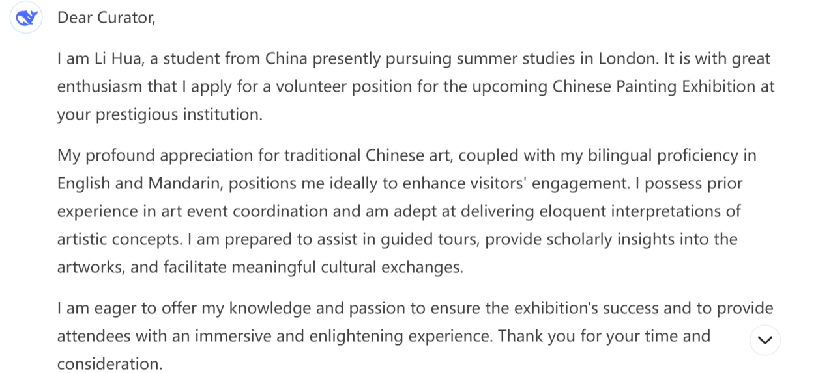

1. Who is the writer of the letter?
2. Who is the receiver of the letter?
3. What is the writer’s writing purpose?

Read and analyze
Find out what is written in each paragraph and match the topics with paragraphs.
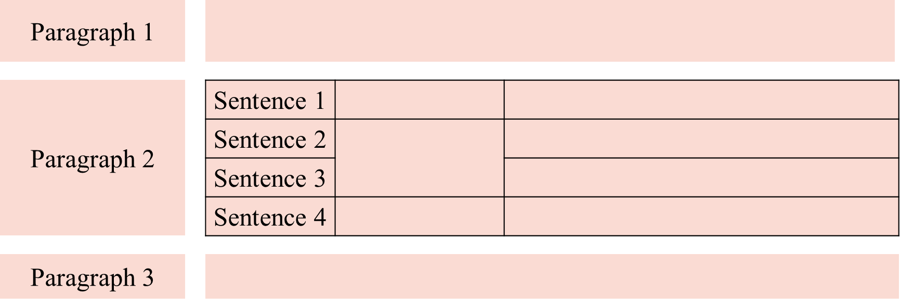

Topics:
self-introduction Point 2 writing purpose gratitude / hope

topic sentence Point 1 writing purpose writing background

Principles of selecting points:
- highly __________ to the position;
- __________ from each other.
Tips for writing an application letter
Tip 1: Figure out the writer, the _________ and the ________________ before you start.
Tip 2: Determine the structure, the _________, the tense, and the person.
Tip 3: Select useful __________ to serve the writing purpose.
Tip 4: Add _______________ to connect sentences logically.
Tip 5: Use __________, __________ and __________ writing style.

Possible sentence patterns
Introduction | 1. Learning from... that you are recruit a(n)..., I would like to apply for the position / vacancy.  2. I’ m writing to you in the hope that I may obtain an opportunity ...  3. I’ m writing to request a valuable chance to be... The following are my advantages.  4. It is with immense confidence that I apply for the admission into ...
Main body | 1. I have exceptional collaborative spirit and can forge a close bond with other people.  2. Not only can I wield (a language) with assurance, but also I am experienced at ...  3. I have been working in... since..., and thus accumulated ample experience in the field.
Ending | 1. Should I be offered the golden opportunity, I would do my utmost in any job assigned to me.  2. I would greatly appreciate it if you could take my application into consideration.  3. I look forward to receiving your positive feedback / affirmative reply.

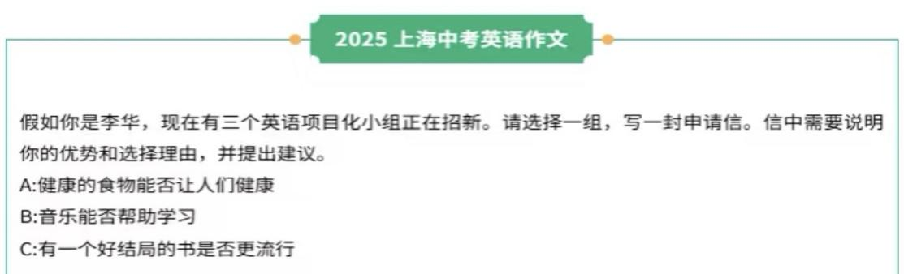
To whom it may concern,
I am Li Hua, a student in our school.

自评： 生评： 师评：
高考应用文评分标准
第五档 (13-15) 优秀，漂漂亮亮
✸无要点遗漏；
✸使用了多样且贴切的词汇和语法结构，错误极少，且完全不影响理解；
✸有效使用了语句间衔接手段，全文结构清晰，意义连贯；
✸完全达到了预期写作目的。
第四档 (10-12) 良好，清清楚楚
✸无要点遗漏；
✸使用了比较多样且恰当的词汇和语法结构，有个别错误，但不影响理解；
✸比较有效地使用了语句间衔接手段，全文结构比较清晰，意义比较连贯；
✸达到了预期写作目的。
第三档 (7-9) 一般，马马虎虎
✸基本覆盖所有要点，有个别表达不清楚、不合理；
✸基本有效地使用了恰当的词汇和语法结构，有些许错误，但不影响理解；
✸基本有效地使用了语句间衔接手段，全文结构基本清晰，意义基本连贯；
✸基本达到了预期写作目的。
其余档次略。

